Name of Event: Workshop on Social Accountability, 2022
Date: 27th December, 2022
Venue: ViSWA, Kanke, Ranchi
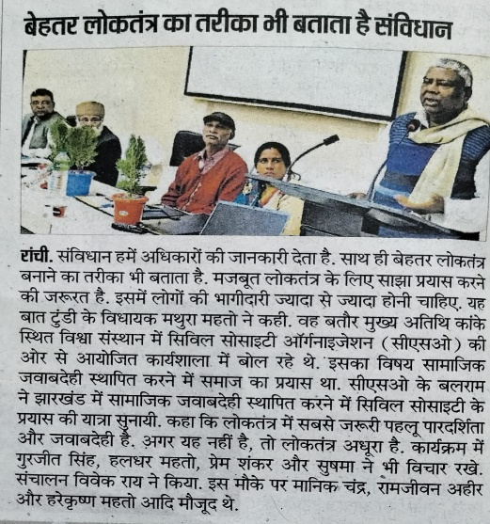
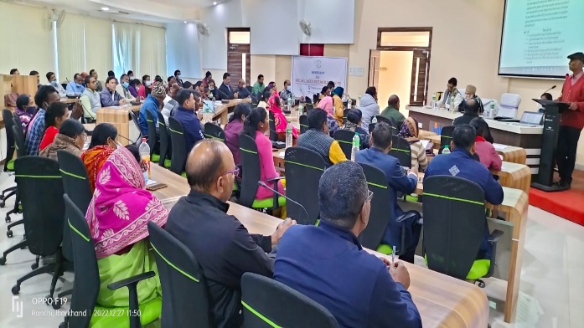
A workshop on Social Accountability was organized by the Jharkhand CSO forum on 27th Dec. 2022 at ViSWA, Kanke. The main idea behind the workshop was to knock and define governance in the changing times. Social accountability is basically an obligation and responsibility on the part of the Government to be answerable to its citizens for its actions and decisions taken. Social accountability ensures the fulfillment of democratic and human rights. It thus forms a bridge between governments and people and upholds the values of our Constitution. “Hamara Paisa Hamara Hisaab”. In a nutshell, it has been defined as an approach towards ensuring accountability that relies on civic engagement, i.e., in which ordinary citizens and citizen groups participate directly or indirectly in exacting accountability. In a public sector context, social accountability refers to a wide range of actions and mechanisms that citizens, communities, independent media, and civil society organizations can use to hold public officials accountable. The effectiveness and sustainability of social accountability mechanisms is improved when they are institutionalized.
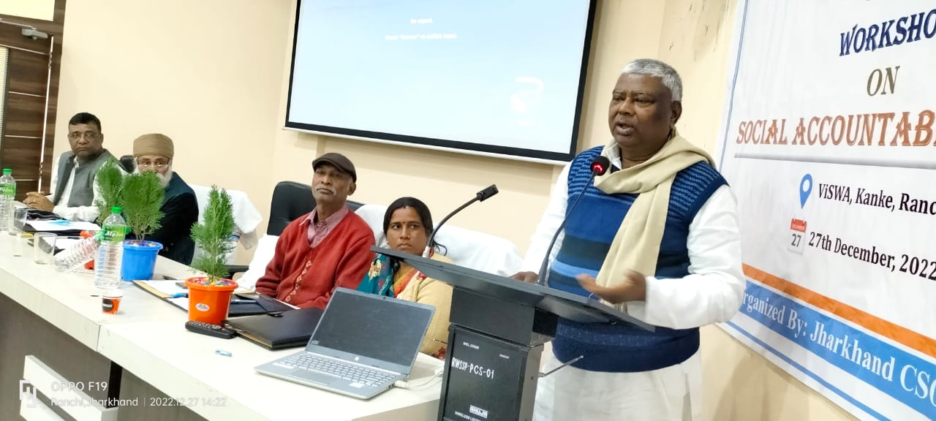
Gracing the occasion, Mr. Mathura Prasad Mahato, MLA from Tundi said that all of us are experienced and we must share our experiences with one another for mutual enhancement of knowledge. In our system of functioning, the government’s eye is people’s representatives like ward members, parliamentarians, social workers etc. These all contribute to make the society effective and functional. Tools like RTI is an instrument to measure the and ensure social accountability progress and update. We have faults in our system and social accountability can be an influential tool to rectify and amend the same if used aptly and with understanding. It is the era of new generation and they should act for development and upliftment of all. This will ensure employment and income for all and more particularly for those in need and distress. We also need to develop markets to ensure an increased income prospect of people.

